**IMAGE PROCESSING PRACTICAL**

**IMAGE PROCESSING PRACTICAL**

**1a - Program to calculate number of samples required for an image:**

**Code:**

clc;

clear all;

fm=input('Input signal frequency');

k=input('no. of cycles');

A=input('Enter amplitude signal');

tm=0:1/(fm*fm):k/fm;

x=A*cos(2*%pi*fm*tm);

figure(1);

a=gca();

a.x_location="origin";

a.y_location="origin";

plot(tm,x);

title('Original Signal');

xlabel('Time');

ylabel('Amplitude');

xgrid(1)

fnsq=2*fm;

fs=(3/4)*fnsq;

n=0:1/fs:k/fm;

x=A*cos(2*%pi*fm*n);

figure(2);

a=gca();

a.x_location="origin";

a.y_location="origin";

plot(n,x);

title('Under Sampling Signal');

xlabel('Time');

ylabel('Amplitude');

xgrid(1)

fnyq=2*fm;

fo=fnyq;

o=0:1/fo:k/fm;

x=A*cos(2*%pi*fm*o);

figure(3);

a=gca();

a.x_location="origin";

a.y_location="origin";

plot(o,x);

title('nyquist Sampling');

xlabel('Time');

ylabel('Amplitude');

xgrid(1)

fo=10*fnyq;

o=0:1/fo:k/fm;

x=A*cos(2*%pi*fm*o);

figure(4);

a=gca();

a.x_location="origin";

a.y_location="origin";

plot2d3('gnn',o,x);

plot(o,x,'r');

title('Over Sampling signal');

xlabel('Time');

ylabel('Amplitude');

xgrid(1)

**output:**

**1b - Program to study the effects of reducing the spatial resolution of a digital image:**

**Output:**

**1c - Program to study the effects of varying the number of intensity levels in a digital image:**

**Output:**

**PRACTICAL 2:**

**P2: A1 Program to perform Image negation:**

**Output:**

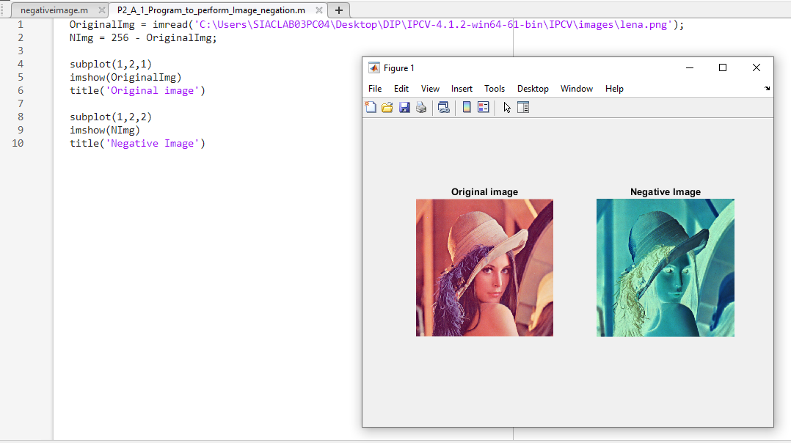

**P2: A2 Program to perform threshold on an image:**

**Output:**

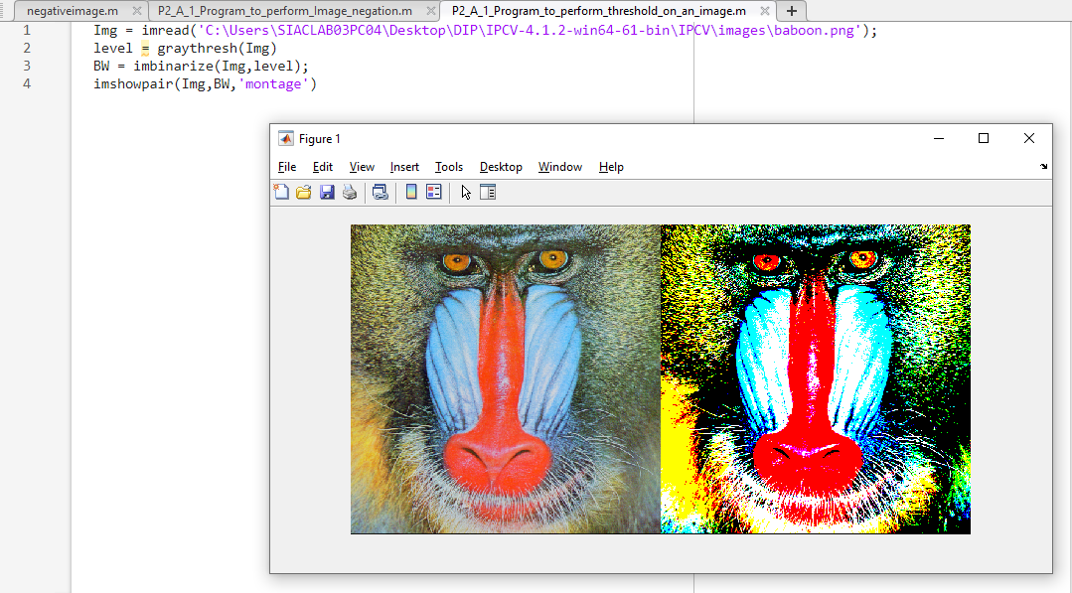

**P2: A3 Program to perform Log transformation in matlab:**

**Output:**

**P2: A4 Power law transformations:**

**Output:**

**P2: A5 (A) Contrast Stretching:**

**Output:**

**P2: B1 Histogram:**

**Output:**

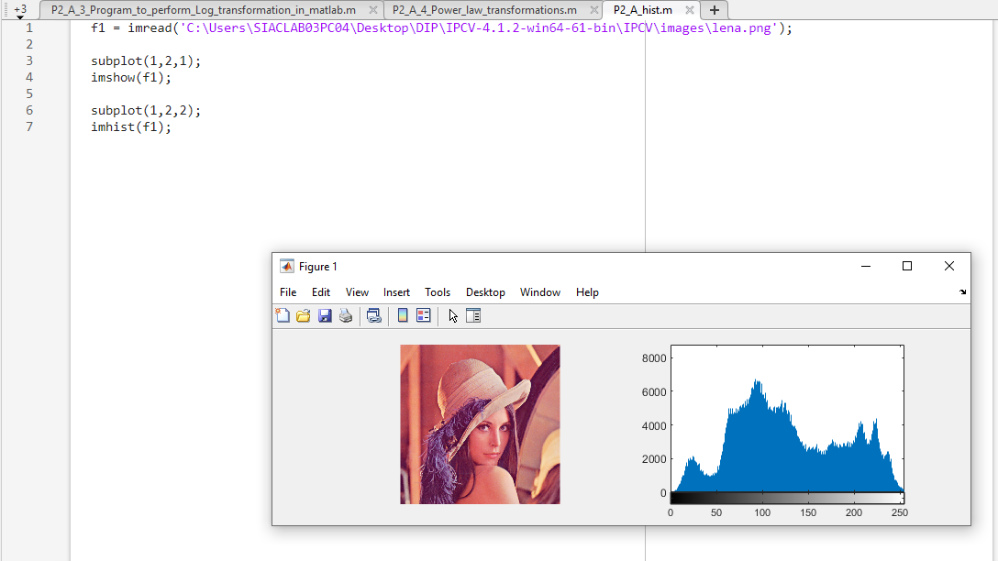

**P2: B2 Histogram Equalization:**

**Output:**

**P2: C convolution Correlation.m:**

**Output:**

